**Reevaluating the Role of BCG Vaccine in COVID-19 Protection: A Comprehensive Meta-Analysis and Systematic Review**

**Kasiful Aprianto1, Mila Desi Anasanti*2**

**1**Computer Science Study Program, Universitas Nusa Mandiri, Jakarta, Indonesia

**2**Department of Information Studies, University College London, London, United Kingdom

**2**Bart and London Genome Center, Queen Mary University of London, London, United Kingdom

**1**14220022@nusamandiri.ac.id, **\*2**mila.mld@nusamandiri.ac.id

Abstract

Background: The Bacillus Calmette-Guerin (BCG) vaccine has been used to treat tuberculosis (TB) for the past decade, but some studies suggest using the BCG vaccine to address the spread of Coronavirus Disease 2019 (COVID-19) cases. This research aims to evaluate the role of the BCG vaccine in preventing COVID-19 infections and reducing the severity of the disease.

Objective: This study conducts a meta-analysis using four specific groups: (1) the role of the BCG vaccine in preventing COVID-19 infections, (2) patients admitted to hospitals, (3) patients requiring ICU care, and (4) patients who died from COVID-19. Each group will be thoroughly analyzed by creating subgroup meta-analyses based on age, patient characteristics, and vaccine types, according to available data.

Methods: The meta-analysis is conducted by gathering data from relevant scientific publications and collecting the number of observations, COVID-19 case numbers, and odd ratios (OR) from each study. Heterogeneity is also assessed to evaluate the significance of the findings. For each main group, we employed the random-effects model as it combines all characteristics of patients. For each subgroup, we utilized the fixed-effects model because each subgroup had been differentiated based on their respective characteristics.

Results: The significant findings not observed in previous research are that the BCG Moscow vaccine has a significant impact on patients admitted to the hospital (p-value = 0.0337) and it significantly benefits adult patients in preventing ICU admission due to COVID-19 (p-value = 0.0117). These findings indicate that the BCG vaccine can play an important role in reducing disease severity and the risk of COVID-19 patients needing intensive care or hospitalization.

Conclusion: Our meta-analysis study on the BCG vaccine's effect on COVID-19 has revealed significant and previously unreported findings. Subgroup analysis based on vaccine types, age, and patient characteristics showed that BCG Moscow vaccine has a significant effect in preventing hospital admissions, and it also demonstrated a positive impact in adult patients, reducing ICU admissions due to COVID-19. While the link between a decrease in mortality risk and the BCG vaccine doesn't exhibit statistical significance, additional research involving more extensive sample sizes is required to validate this finding. These findings have crucial implications for future pandemics or outbreaks, suggesting BCG vaccine as an additional tool in prevention and treatment strategies. It highlights its potential in providing specific protection for certain populations and reducing disease severity in COVID-19 patients, especially for adult patients and those below 60 years of age. Overall, our study offers crucial perspectives for addressing contagious illnesses and steering the creation of improved measures for prevention and therapy amidst forthcoming health-related adversities.

Keywords: BCG vaccination, COVID-19, Meta-analysis, Randomized controlled trials, Protective efficacy

# Introduction

Since the conclusion of 2019, the COVID-19 virus has led to a worldwide pandemic. Efforts to develop vaccines are ongoing to combat the COVID-19 virus. Several studies have found that the Bacillus Calmette-Guerin (BCG) vaccine, originally used to prevent tuberculosis (TB), may also provide general protection against various infectious microorganisms. Some investigations indicate that the potential non-specific protective impacts of the BCG vaccine could offer advantages in addressing viral infections [1]–[5]. Other research states that the BCG vaccine also provides protection by altering the characteristics of immune cells called monocytes through epigenetic mechanisms [2], and by inducing non-specific immunological effects [6], [7]. Despite the complete mechanism of safeguarding not having been comprehensively elucidated, it is posited that the BCG vaccine elicits both innate and adaptive immune reactions against a spectrum of pathogenic agents, whether originating from within or outside the body [1]–[7].

Based on several studies, the BCG vaccine demonstrated significant non-specific protective effects in reducing mortality rates. This protective outcome encompasses both innate and adaptive immune reactions and encompasses a range of factors. A randomized clinical trial, for instance, discovered that the administration of the BCG-Danish vaccine to newborns weighing less than 2500 g resulted in a decrease in neonatal mortality rates [8]. Other studies also showed that BCG vaccination at birth reduced hospitalization rates in early childhood [9]. Moreover, additional studies suggested that the BCG vaccine augmented the immunogenicity of influenza vaccines in individuals who were in good health [10].

Furthermore, certain epidemiological investigations propose that the BCG vaccine exhibits non-specific antibacterial properties. Notably, in Guinea-Bissau, vaccination with BCG was linked to elevated survival rates among children [11]. Overall, the BCG vaccine has shown potential in reducing mortality rates and providing broad-spectrum protection against various infections. However, despite some studies supporting the non-specific protective effects of the BCG vaccine, the findings are still inconsistent.

Concerning the COVID-19 pandemic, ongoing research is being conducted regarding the overall COVID-19 prevention effects of the BCG vaccine. Recent investigations have indicated a connection between BCG vaccination and less severe symptoms of COVID-19 [12]–[18]. Additional research suggests that the BCG vaccine may be able to lessen the severity of COVID-19 infections [12]. These findings support the idea that the non-specific innate immune process might underlie the increased protection against viral infections, especially COVID-19, provided by the BCG vaccine.

On the other hand, some studies did not uncover substantial evidence supporting the BCG vaccine's effectiveness in preventing COVID-19 infections [19]–[26]. Gong et al. also concluded that how well the BCG vaccine protects against COVID-19 infections is not supported by sufficiently strong data [27]. It is imperative to recognize that ongoing research aims to gain a deeper understanding of the COVID-19 effects of the BCG vaccine and whether it can provide significant non-specific protection. Consistent results emphasize the need for more extensive research with larger samples and enhanced precision in observations to comprehend how the BCG vaccine works to fight the virus.

For this study, to explore the effects of the BCG vaccine on COVID-19, our study conducted a meta-analysis and systematic review. The previous introduction has provided an informative summary of the BCG vaccine and its potential in combating COVID-19 based on meta-analytical research [28]. However, to increase knowledge of the BCG vaccine's effectiveness against COVID-19, our meta-analysis study has several important advantages. Firstly, our research collected additional data that were not considered in previous studies, providing a more comprehensive insight into The potential for COVID-19 protection provided by the BCG vaccine. This additional data includes the results of recent studies as well as larger and diverse population cohorts. By combining data from various sources, we can provide a broader perspective on the effect of the BCG vaccine on infections with COVID-19.

Moreover, our research delved deeper into subgroups of the population to identify factors influencing how well the BCG vaccine works in providing protection against COVID-19. Through subgroup analysis, we hope to uncover the variability of immune responses and the benefits of the BCG vaccine for protection in different population groups. The results of this exploration can provide valuable insights for formulating targeted and effective vaccination strategies, especially considering the differences in population characteristics.

The results of our research are expected to significantly contribute to the global understanding of the BCG vaccine's role in battling the COVID-19 pandemic. We hope that our findings will further support the significant non-specific protection potential of the BCG vaccine and provide a strong scientific basis for the development of vaccination strategies to effectively address the challenges of this global pandemic. Utilizing additional data and comprehensive subgroup exploration, our study aims to contribute valuable knowledge in the face of this global pandemic.

# Data Collection and Studies Selection

The literature search commenced by searching electronic databases, including PubMed, Google Scholar, Crossref, OpenAlex, and Scopus. The keywords used were "BCG," "COVID," "randomized controlled trials," "RCT," and "cohort." The search was limited to articles published up to April 2023. the article titles and abstracts produced by the literature search were then screened for eligibility based on inclusion criteria. Studies using cohort studies or randomized controlled trials (RCTs) assessing the effects of the BCG vaccine on COVID-19 were included in the inclusion criteria. Relevant articles were chosen for additional examination.

The relevant data collected includes the study design, the number of participants, population characteristics, BCG vaccine intervention, measured outcomes (e.g., infection rates, mortality rates), and statistical results. This data was independently extracted by researchers and verified for consistency. Data extracted from studies meeting the inclusion criteria were analyzed using meta-analysis methods.

For this study, we selected journals that meet the criteria described in the Table 1:

Table 1. Characteristics and Parameters of the Study Population, Intervention, Control, and Outcome for Evaluating COVID-19 Protection from the BCG Vaccine.

|  |  |
| --- | --- |
| **Criteria** | **Description** |
| Population (P) | Participants are individuals aged at least 17 years. Participants who have undergone COVID-19 testing with Polymerase Chain Reaction (PCR) or antigen testing methods and tested positive for the virus are considered COVID-19 patients. Gender, race, ethnicity, or geographic distribution are not restricted. |
| Intervention (I) | Participants received the BCG vaccine with any dosage. |
| Control/Placebo (C) | Participants were not given any treatment or only received an empty injection (placebo). |
| Outcome (O) | The efficacy of the BCG vaccine is determined based on the total number of COVID-19 patients who (a) were identified through PCR/rapid antigen/serological testing, (b) were hospitalized, (c) were admitted to intensive care units, and (d) passed away. |

In this meta-analysis study, we will conduct subgroup analysis for each outcome to identify factors influencing BCG vaccination's impact on COVID-19. Some subgroups included in this analysis are: (1) Vaccine Type: Danish Strain, VPM1002, BCG Moreau, BCG Moscow, Tokyo 172 Strain; (2) Age: 60 years or older, and under 60 years; (3) Characteristics: Health Care Workers (HCW), and Adults;

We will combine data from studies meeting the inclusion criteria for each subgroup. It is important to note that the mentioned subgroups will be adjusted based on the number of available studies to ensure that the analysis has sufficient statistical reliability. We will use at least two studies in each subgroup to ensure more reliable analysis results [29].

1. Methodology

Using Publish or Perish version 8 [30], a total of 1,624 publications matching the given keywords were successfully found. There were 269 publications that were duplicates based on their titles and DOIs obtained. Using the R programming language [31], all duplicate data was extracted from one dataset and merged back into the dataset, resulting in 1,355 publications without duplicates. Subsequently, the publications were re-examined by checking their abstracts for the search keywords. The search criteria were applied to both abstracts and titles to filter down to 203 publications. Finally, the content of the filtered publications was examined one by one. For this study, a total of 16 sources were utilized. The following is the Preferred Reporting Items for Systematic Reviews and Meta-Analyses (PRISMA) flow diagram for conducting the literature search.

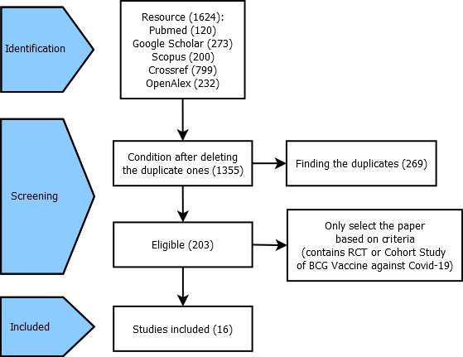

Figure 1. PRISMA flow diagram

The characteristics of each obtained publication are summarized in the Table 2. There are 16 publications, including 9 MultiCentre RCT studies and 4 SingleCentre RCT studies, as well as 3 cohort studies. Additionally, there are 10 healthy adult patients and patients with a history of up to four publications. Patients tested positive for COVID-19 up to ten publications and patients with symptoms up to four publications were diagnosed.

Table 2. The characteristics of each obtained publication

|  |  |  |  |  |  |  |  |  |  |  |  |
| --- | --- | --- | --- | --- | --- | --- | --- | --- | --- | --- | --- |
| Study Design | Study | Year Published | Participant Characteristics | | | | | Study Characteristics | | | |
| Characteristics | Age | Sex (%) | | Total | Group | | Diagnosis | Timing of follow-up |
| Male | Female | Intervention | Control |
| (BCG Vaccinated) | (Placebo) |
| (1) | (2) | (3) | (4) | (5) | (6) | (7) | (8) | (9) | (10) | (11) | (12) |
| RCT multi center | Claus [32] | 2023 | Adults (Health Care Workers) | 42.49 (mean) | 25.6 | 74.41 | 1,309 | Danish Strain | Placebo | Based on participant self-reports (serologic test) | 90 days |
| RCT multi center | Koekenbier [21] | 2023 | Adults | 69 (median) | 62.8 | 37.22 | 6,112 | Danish Strain | Placebo | Participant self-reports + hospital records (if relevant) | 180 days |
| RCT multi center | Pittet [33] | 2023 | Healthcare workers | 42.8 (mean) | 25.4 | 74.6 | 3,386 | BCG Denmark | Placebo | Patients infected with SARS-CoV-2 (PCR / rapid antigen / serologic test) + death/hospitalization / severe disease (≥3 consecutive days unable to work) | 6 months |
| RCT multi center | Santos [9] | 2023 | Adults (Health Care Workers) | 18 to 60+ | 20.5 | 79.55 | 264 | BCG Moreau or BCG Moscow | Placebo | PCR (Positive) | 180 days |
| RCT multi center | Blossey [18] | 2022 | Adults | 67.3 (mean) | 52.9 | 47.1 | 2,025 | VPM1002 | Placebo | PCR (Positive) | 240 days |
| RCT multi center | Czajka [20] | 2022 | Healthcare workers | 45 (mean) | 19.3 | 80.7 | 342 | BCG Moreau | Placebo | PCR (Positive) | 3 months |
| RCT multi center | Doesschate [22] | 2022 | Healthcare workers | 42 (mean) | 25.7 | 74.3 | 1,511 | Danish Strain | Placebo | PCR (Positive) | 26 weeks |
| RCT single center | Dos Anjos [15] | 2022 | Healthcare workers | 43 (mean) | 23.7 | 76.3 | 131 | BCG Moscow | Unvaccinated | PCR or rapid antigen test (Positive) | 180 days |
| RCT single center | Faustman [26] | 2022 | Patients with type 1 diabetes | 43,8 (mean) | 58.3 | 41.7 | 144 | Multiple Tokyo 172 strain | Placebo | Symptoms and PCR (Positive) | 15 months |
| RCT single center | Moorlag [35] | 2022 | Adults | 67 (mean) | 52.5 | 47.5 | 2,014 | Danish Strain | Placebo | PCR (Positive) | 12 months |
| RCT multi center | Sinha [16] | 2022 | Adults’ underlying medical conditions | 43 (mean) | 52.1 | 47.9 | 495 | BCG Moscow | Placebo | PCR (Positive) | 9 months |
| RCT single center | Tsilika [14] | 2022 | Adults at risk | 69 (mean) | 67.8 | 32.2 | 301 | BCG Moscow | Placebo | PCR (Positive) | 6 months |
| RCT multi center | Upton [25] | 2022 | Healthcare workers | 39 (mean) | 29.6 | 70.4 | 1,000 | Danish Strain | Placebo | PCR (Positive) | 52 weeks |
| Cohort Study | Weng [36] | 2020 | Adults | 39.5 (median) | 25 | 75 | 120 | BCG Vaccine | Placebo | Obtain to Hospital | Unknown |
| Cohort Study | Amirlak [37] | 2021 | Emirates International Hospital (All staff) | 21 to 80 | n.a | n.a | 280 | Booster BCG Vaccine | Unvaccinated | PCR (Positive) | 3 months |
| Cohort Study | Begam [38] | 2022 | Patient infected COVID-19 | 15 to 75 | 76.5 | 23.4 | 205 | BCG Vaccine | Unvaccinated | Obtain to ICU | continued until the desired result was reached |

The table summarizes the characteristics of studies conducted to evaluate how well the BCG vaccine protects against COVID-19. In this research, various study designs involving diverse participant populations, including adults and healthcare workers, were used. The types of BCG vaccines used also varied, including BCG Moreau, BCG Moscow, or BCG Danish Strain. The control groups in these studies received either a placebo or were not vaccinated. COVID-19 was diagnosed using positive PCR or rapid antigen test results, with surveillance periods ranging from several weeks to several months. The information from this table is useful for understanding the impact of BCG immunization on COVID-19, especially in the context of diverse populations.

For the results, we used statistical methods to combine findings from the included research analyses. Continuous variables will be represented by standard deviation (SD) and mean, and dichotomous variables by frequency and percentage. Effect size will be presented using odds ratio (OR) with confidence interval (CI) displayed in a forest plot. Heterogeneity between studies will be assessed using the chi-square Q test and I^2 statistics, with I^2 > 50% indicating significant heterogeneity.

When choosing between the random-effects and fixed-effect models for meta-analysis, three important factors were considered. Firstly, the random-effects model was thought to be more appropriate if there were variations in the studies' findings. This was due to the fact that this model considered the variations between the studies resulting from participant characteristics, intervention techniques, or research methodologies used in each study. Secondly, when the number of studies was limited or the sample sizes were small, the fixed-effect model was selected. This model assumed that the effect was the same across all studies, thereby not accounting for inter-study variations. Lastly, when there were variations in study quality, the fixed-effect model was found to be a better fit. This model assigned greater weight to studies with larger sample sizes and better quality, thus dampening the influence of lower-quality studies on the meta-analysis results [39]. Therefore, the random-effects model was employed for each main group as it combined all the characteristics present in the subgroups, while the fixed-effect model was used for each subgroup as each characteristic had been separated for more in-depth research.

# Results

## Number of Respondents Affected by COVID-19

This meta-analysis included 13 studies with 15,928 observations and 1,210 cases in total. In the general effects model, an odds ratio (OR) of 0.92 (with 95% CI: 0.72 - 1.16) is determined. A z-value of -0.80 and a p-value of 0.4420 suggested that, statistically, there was no significant difference for each group (intervention and control).

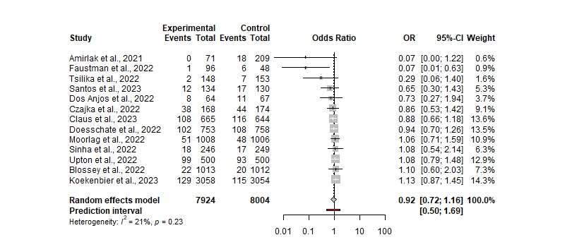

Figure 2. The odds ratio of respondents being infected with COVID-19 (Forest Plot)

In addition, the heterogeneity analysis revealed that the variation across studies (tau^2) was 0.0655 (with 95% CI: 0.0000 - 1.5230) with a tau value of 0.2558. (95 percent -CI: 0.0000 - 1.2341). The I^2 score of 21.1% suggests a low degree of heterogeneity across research, however, the H value of 1.13 reveals impact variation among studies. The heterogeneity test with a Q value of 15.22 and a degree of freedom (d.f.) of 12 produced a p-value of 0.2298, indicating that heterogeneity across studies was not significant.

Table 3. Subgroup Meta-Analysis Summary: Impact of Vaccine Type, Age, and Patient Characteristics on COVID-19 Efficacy among Respondents Affected by COVID-19

|  |  |  |  |  |  |  |
| --- | --- | --- | --- | --- | --- | --- |
| **Subgroup** | **Category** | **Number of Studies** | **Number of Observations** | **Number of Cases** | **Effect Model**  **(p-values)** | **Heterogeneity (p-values)** |
| Vaccine Type | Danish Strain | 5 | 11,946 | 969 | 0.8412 | 0.7399 |
| BCG Moscow | 3 | 927 | 63 | 0.4142 | 0.3081 |
| Age | >=60 | 7 | 4,932 | 769 | 0.3404 | 0.3345 |
| <60 | 4 | 10,452 | 394 | 0.4758 | 0.4232 |
| Patient Characteristic | HCW | 6 | 4,557 | 756 | 0.3485 | 0.8335 |
| Adults | 7 | 11,371 | 454 | 0.9469 | 0.0572 |

By categorizing the data into several subgroups (based on vaccine types, age, and characteristics), all the results consistently showed the same conclusion, indicating that there was no discernible difference between the control and intervention groups (p-value for each effect model > 0.05). Therefore, overall, we can draw the conclusion that the BCG vaccine has no effect on preventing COVID-19 infection, regardless of the population's specific vaccine type (Danish Strain and BCG Moscow), age (less than 60 years and over 60 years), or patient characteristics (HCW and Adults).

## COVID-19 Respondents Admitted to Hospital

In this meta-analysis, the effect of the BCG vaccination against COVID-19 was investigated using hospitalized COVID-19 patients from the intervention and control groups. Ten studies were included, with a total of 17,095 observations and 120 cases. With an odds ratio (OR) value of 0.67, we found that The BCG vaccination did not lower the likelihood of contracting COVID-19 (with 95% CI: 0.3351 to 1.3417). This finding is represented by a p-value of 0.2247, showing that BCG vaccination does not increase the risk of COVID-19 infection in hospitalized patients.

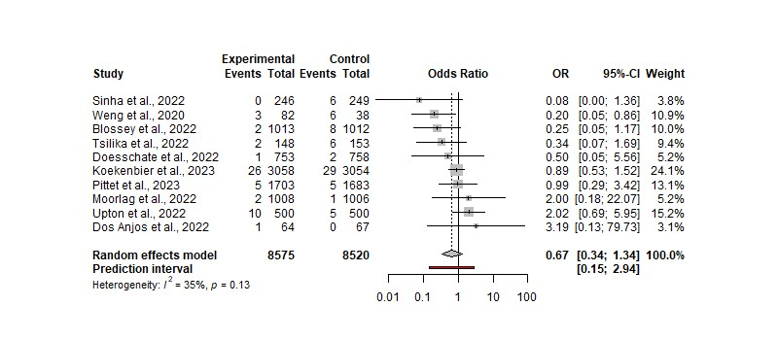

Figure 3. The odds ratio of respondents being admitted to the hospital (Forest Plot)

Analysis of heterogeneity showed variation between the studies involved, with an estimated variance between studies (tau^2) of 0.3161 and an I-squared value (I^2) of 34.8%. Heterogeneity testing using statistical Q showed no statistical significance (p-value = 0.1292). Thus, the results suggest that there is variation between the studies involved, but there is not enough information to establish that the vaccination has a consistent impact on the risk of COVID-19 infection in hospitalized patients.

Table 4. Subgroup Meta-Analysis Summary: Impact of Vaccine Type, Age, and Patient Characteristics on COVID-19 Efficacy among Respondents Admitted to Hospital

|  |  |  |  |  |  |  |
| --- | --- | --- | --- | --- | --- | --- |
| **Subgroup** | **Category** | **Number of Studies** | **Number of Observations** | **Number of Cases** | **Effect Model**  **(p-values)** | **Heterogeneity (p-values)** |
| Vaccine Type | Danish Strain | 4 | 10,637 | 76 | 0.8203 | 0.4947 |
| BCG Moscow | 3 | 927 | 15 | 0.0337 | 0.2357 |
| Age | >=60 | 4 | 10,452 | 76 | 0.1714 | 0.2658 |
| <60 | 6 | 6,643 | 15 | 0.2721 | 0.0806 |
| Patient Characteristic | HCW | 4 | 6,028 | 76 | 0.3562 | 0.6382 |
| Adults | 6 | 11,067 | 44 | 0.0117 | 0.1107 |

Based on the meta-analysis results for each subgroup (as shown in Table 4), both the subgroup of patient characteristics category Adults and the subgroup of vaccine type category BCG Moscow showed statistically significant differences between the intervention and control groups (p-value = 0.0117 and 0.0337). However, for the other subgroups (Danish strain vaccine type, all ages, and HCW characteristics), the control group and the intervention group did not differ from one another (with p-values > 0.05).

For the subgroups with significant results (BCG Moscow vaccine type subgroup and Adults characteristics subgroup), the forest plot for each finding are presented as follows:

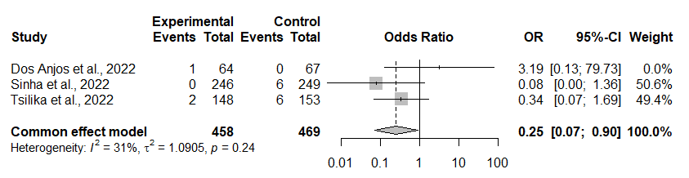

Figure 3. Odds Ratio of patients admitted to the hospital for BCG Moscow vaccine type subgroup (Forrest plot)

Based on the forest plot above, with a p-value of 0.0337, it can be observed that the group of patients given the BCG vaccine has a lower rate compared to the control group. The results also indicate that there is no heterogeneity in the collected data (p-value = 0.24). This suggests that the BCG effect significantly provides a positive impact on the body's resistance to prevent patients with BCG Moscow vaccine from being admitted to the hospital.

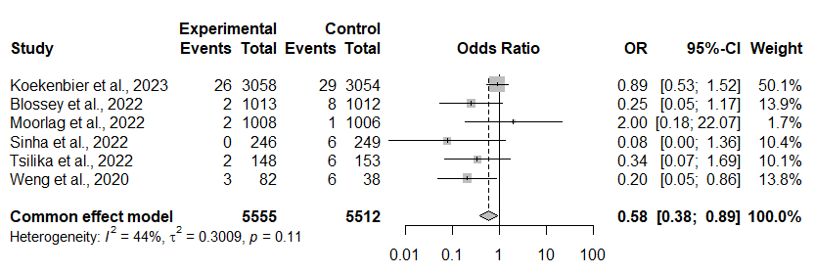

Figure 4. Odds Ratio of patients admitted to the hospital for Adults characteristics subgroup (Forrest plot)

Furthermore, based on the forest plot above (with a p-value of 0.0117), it can be observed that the group of patients given the BCG vaccine has a lower rate compared to the control group. The results also indicate that there is no heterogeneity in the collected data (p-value = 0.11). This suggests that the BCG effect significantly provides a positive impact on the body's resistance to prevent adult patients from being admitted to the hospital.

## COVID-19 Respondents Admitted to the ICU

In this result, we assessed the role of BCG immunization in COVID-19 intensive care unit admissions by comparing the intervention group to the control group (ICU). Five studies with a total of 4,859 observations satisfied the inclusion criteria.

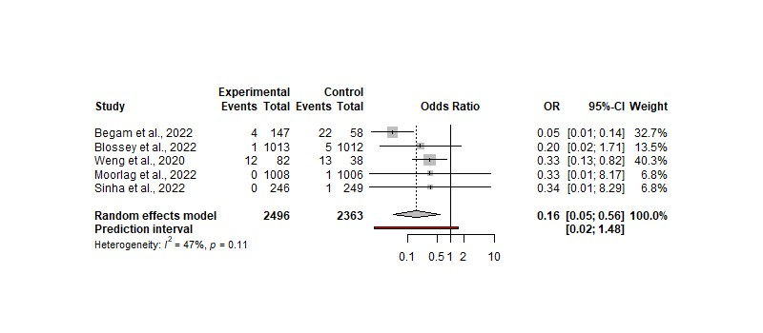

Figure 5. The odds ratio of respondents being admitted to ICU with COVID-19 (Forest Plot)

The research indicated that the general effects model had an odd ratio (OR) value of 0.16 with a 95% CI ranging from 0.05 to 0.56. The difference between the intervention group and the control group is statistically significant, as shown by the z-value of -4.07 and the p-value of of 0.0153.

Furthermore, heterogeneity was measured using the tau-squared statistic (τ^2) which is 0.2835 with a 95% CI between 0.0000 and 5.4315, and a tau (τ) value of 0.5324 with a 95% CI between 0.0000 and 2.3306. The I-squared statistic (I^2) shows a heterogeneity rate of 47.5% with a range of 0.0% to 80.8%, while the H factor (heterogeneity factor) has a value of 1.38 with a 95% CI between 1.00 and 2.28. The heterogeneity test showed a statistical Q result of 7.61 with a degree of freedom (d.f.) of 4, and a p-value of 0.1068, indicating insignificant heterogeneity among the studies analyzed.

Table 5. Subgroup Meta-Analysis Summary: Impact of Vaccine Type, Age, and Patient Characteristics on COVID-19 Efficacy among Respondents Admitted to ICU

|  |  |  |  |  |  |  |
| --- | --- | --- | --- | --- | --- | --- |
| **Subgroup** | **Category** | **Number of Studies** | **Number of Observations** | **Number of Cases** | **Effect Model**  **(p-values)** | **Heterogeneity (p-values)** |
| Age | >=60 | 2 | 4,039 | 7 | 0.0965 | 0.7944 |
| <60 | 2 | 615 | 26 | 0.0106 | 0.991 |
| Patient Characteristic | HCW | - | - | - | - | - |
| Adults | 5 | 4,859 | 59 | < 0.0001 | 0.11 |

To examine more specific results, subgroup analyses were conducted. There were 2 subgroup meta-analyses for patients admitted to the ICU, namely the age subgroup (age greater than or equal to 60 years and age less than 60 years) and the patient characteristics subgroup (Adults). HCW patients were not included due to limited data available. The outcomes indicated a significant difference between the intervention and control groups for patients under the age of 60 in the age subgroup (p-value = 0.0106), but not significant for patients above 60 years old. The intervention and control groups significantly differed from one another for the patient characteristics subgroup classified as adults (p-value < 0.0001).

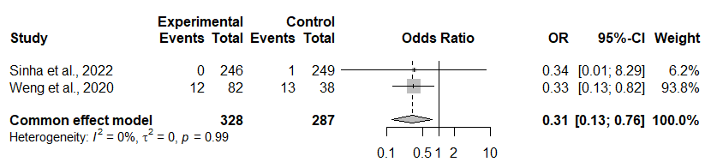

Figure 6. Odds Ratio of patients admitted to the ICU for the age subgroup under 60 years old (Forest plot)

Based on the forest plot above, with a p-value of 0.0106, it can be seen that the group of patients given the BCG vaccine has a lower rate compared to the control group. The results also indicate that there is no heterogeneity in the collected data (p-value = 0.99). This suggests that the BCG effect significantly provides a positive impact on the body's resistance to prevent patients under 60 years old from being admitted to the ICU.

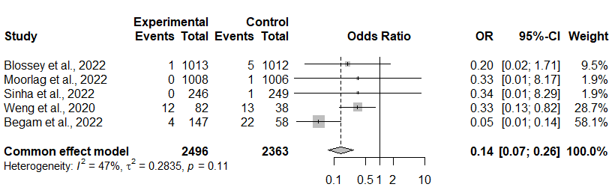

Figure 7. Odds Ratio of patients admitted to the ICU for the patient characteristics subgroup categorized as adults (Forest plot)

Based on the forest plot above, with a p-value less than 0.0001, it can be seen that the group of patients given the BCG vaccine has a lower rate compared to the control group. The results also indicate that there is no heterogeneity in the collected data (p-value = 0.11). This suggests that the BCG effect significantly provides a positive impact on the body's resistance to prevent adult patients from being admitted to the ICU.

## Respondents Who Passed Away Due to COVID-19

In the general effects model, the odds ratio (OR) was 0.57, according to the findings of this meta-analysis of 8 studies, 15,408 observations, and 22 COVID-19 patients who passed away. (with 95 % CI: 0.27 - 1.18). With a p-value of 0.1118, the statistical test's findings showed that there was no statistically significant difference between the intervention and control groups.

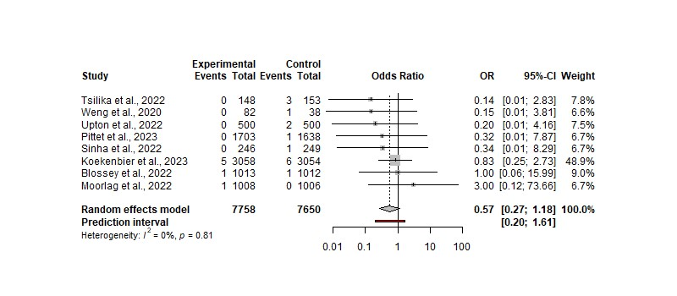

Figure 8. The odds ratio of respondents who died due to COVID-19 (Forest Plot)

Furthermore, heterogeneity analysis showed that the variance between studies (tau^2) was 0 (95%-CI: 0.0000 - 2.3549), with tau values of 0 (95%-CI: 0.0000 - 1.5346). An I^2 value of 0.0% indicates a low degree of heterogeneity between studies, and an H value of 1.00 indicates variation in effects between studies. The heterogeneity test with a Q value of 3.73 and a degree of freedom (d.f.) of 7 yielded a p-value of 0.8100, which showed insignificant heterogeneity between studies. Please note that the death rate experienced by patients is the death rate caused by COVID-19. As for the publication from Weng et al, the death rate presented consisted of one person who was not vaccinated against BCG, but the cause of death was not clearly explained [36]. For this study, we assumed that the mortality rate was indicated by the COVID-19 mortality rate.

Table 6. Subgroup Meta-Analysis Summary: Impact of Vaccine Type, Age, and Patient Characteristics on COVID-19 Efficacy among Respondents Who Passed Away

|  |  |  |  |  |  |  |
| --- | --- | --- | --- | --- | --- | --- |
| **Subgroup** | **Category** | **Number of Studies** | **Number of Observations** | **Number of Cases** | **Effect Model**  **(p-values)** | **Heterogeneity (p-values)** |
| Vaccine Type | Danish Strain | 3 | 9,126 | 14 | 0.5925 | 0.4815 |
| BCG Moscow | 2 | 796 | 4 | - | 0.7058 |
| Age | >=60 | 4 | 10,452 | 17 | 0.4742 | 0.5822 |
| <60 | 4 | 4,956 | 5 | - | 0.9829 |
| Patient Characteristic | HCW | - | - | - | - | - |
| Adults | 6 | 11,067 | 19 | 0.2305 | 0.6906 |

By categorizing the data into several subgroups (based on vaccine type, age, and characteristics), all results show the same conclusion, which is that the intervention and control groups do not differ in a significant way (p-value for the effect model > 0.05). Overall, it is possible to draw the conclusion that the BCG vaccine has no effect in preventing COVID-19 deaths in populations with particular vaccine types (Danish Strain and BCG Moscow), age groups (less than 60 years and over 60 years), or patient characteristics (Adults).

Specifically for the subgroup of BCG Moscow vaccine type, there were 4 cases of mortality in the control group, and no recorded mortality figures for patients in the intervention group. Similarly, for the Age Subgroup under 60 years old, there were 5 cases of mortality in the control group, but none in the intervention group. Considering the current state of the data, we are not able to perform a meta-analysis for both of these groups. However, it should be noted that there is strong indication of the role of BCG vaccine in preventing mortality for both of these groups, although further investigation is necessary regarding other factors that may contribute to these mortality cases.

## Publication Bias

|  |  |
| --- | --- |
| (a) | (b) |
| (c) | (d) |

Figure 9. Funnel plot with (a) Number of Respondents affected by COVID-19, (b) COVID-19 Respondents Admitted to the Hospital, (c) COVID-19 Respondents Admitted to the ICU, and (d) Respondents Who Died Due to COVID-19

This asymmetry in the funnel plot may indicate publication bias, in which studies with smaller sample sizes and stronger effects are more likely to be published than those with larger sample sizes and lesser effects.

|  |  |
| --- | --- |
| (a) | (b) |
| (c) | (d) |

Figure 10. Drapery plot with (a) Number of Respondents affected by COVID-19, (b) COVID-19 Respondents Admitted to the Hospital, (c) COVID-19 Respondents Admitted to the ICU, and (d) Respondents Who Died Due to COVID-19

Table 7. The Egger’s Test

|  |  |  |  |  |
| --- | --- | --- | --- | --- |
| **Study** | **interception** | **95% CI** | **t** | **p** |
| (a) By infection rate | -1.626 | -2.39 - -0.86 | -4.157 | 0.001597082 |
| (b) Based on patients admitted to the hospital | -0.692 | -2.16 – 0.78 | -0.921 | 0.3841519 |
| (c) Based on patients admitted to the ICU | 0.261 | -2.74 – 3.26 | 0.17 | 0.8755478 |
| (d) Based on mortality | -0.783 | -1.98 - 0.42 | -1.279 | 0.2480334 |

Egger's test is a statistical tool for detecting publication bias in observational research. This investigation examines Egger's test findings across four categories: infection rates, hospitalized patients, intensive care unit (ICU) patients, and mortality rates.

First, for the infection rate category, Egger's test results showed an intercept of -1.626 with a 95% confidence interval between -2.39 to -0.86. The t-value is -4.157, with a p-value of 0.001597082. This implies a strong link between infection rates and potential publication bias. These results suggest that studies with higher infection rates tend to be more likely to be published compared to studies involving lower infection rates.

Furthermore, for the category of hospitalized patients, the results of Egger's test showed an intercept of -0.692 with a 95% confidence interval between -2.16 to 0.78. The resulting t-value is -0.921, and the p-value of 0.3841519. These results suggest that hospitalized patients and publication bias are unrelated. In other words, the rate of hospitalized patients did not have a significant effect on the likelihood of publication bias.

For the category of patients admitted to the ICU, the results of the Egger's test showed an intercept of 0.261 with a 95% confidence interval between -2.74 to 3.26. The resulting t-value is 0.17, with a p-value of 0.8755478. These results suggest that the risk of publication bias does not significantly relate to either of the two patient groups admitted to the ICU. That is, the likelihood of publication bias was not significantly impacted by the rate of patients admitted to the ICU.

Finally, for the mortality rate category, Egger's test results showed an intercept of -0.783 with a 95% CI between -1.98 to 0.42. The resulting t-value is -1.279, with a p-value of 0.2480334. These findings indicate that there is no correlation between fatality rates and the possibility of publication bias. As a result, mortality rates have little impact on the likelihood of publication bias.

Overall, the results of Egger's tests in the four categories showed a significant relationship between infection rates and the likelihood of publication bias. However, no significant association was found between hospitalized patients, ICU-admitted patients, mortality rates, and possible publication bias. These results provide important insights into understanding possible publication bias in the context of research and can be used as a foundation for more accurate and transparent decision-making.

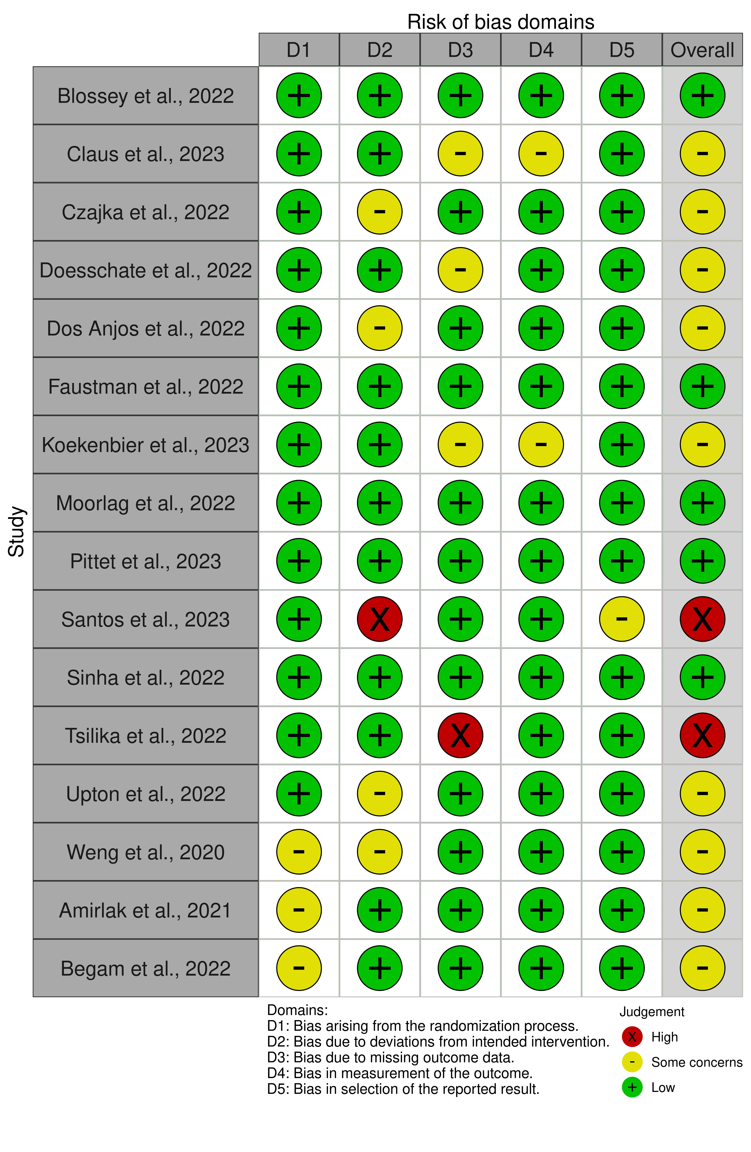

Figure 11. Evaluation of the studies' bias risk in terms of quality

As shown in the image above, there are several publications that have been identified as being biased. There are 5 publications rated as having low bias, 2 publications rated as having high bias, and 9 publications that remain of concern.

# Discussion

Based on previous meta-analysis research conducted by Wen et al., there are similarities in the results we obtained although we have added the latest data in this study using both RCT publications and cohort studies. There were no significant outcomes for COVID-19 patients who were hospitalized or who died, although both showed a tendency towards the effect of BCG vaccine administration and could not be statistically confirmed [28]. Interestingly, however, our results show that there was a significant difference in the number of patients admitted to the ICU between the intervention and control groups. Looking at the results obtained from the previous meta-analysis, if there is a nearly significant skew for patients admitted to the ICU (p-value=0.08) [28], we find a significant result (p-value = 0.0153) by adding some of the data findings. Our findings corroborate previous research that there is a positive effect for patients affected by COVID-19 in reducing disease severity until they are admitted to the ICU. As for the severity of hospitalization or death, the results obtained still do not show significance.

Rakshit et al also studied how BCG revaccination affects the Oxford/AstraZeneca ChAdOx1nCoV-19 or COVISHIELDTM vaccine's qualitative and quantitative antibody and T-cell responses. Subjects who received BCG revaccination showed significant and sustained improvements in neutralization antibody titers against the spike protein, as well as CD4+ and CD8+ polyfunctional T cell responses, including subsets of CD4+IFN-g+ and CD4+IFN-g- effector memory expressing IL-2, TNF-a, and CD154/CD137 activation markers, and a combination of CD8+IFN-g+ and CD8+IFN-g- In response to the Delta strain, the BCG revaccinated group produced more neutralizing antibodies and T cells. BCG adjuvant action is mechanically linked to increased IL-1b and TNF- production in CD14+HLA-DR+ monocytes and BCG-induced epigenetic abnormalities in chromatin accessibility. This finding supports the use of BCG as an adjuvant to boost heterologous adaptive immune responses to COVID-19 vaccines currently available and in development [40]. It is the first in-depth analysis of the immune and memory T cell responses to COVISHIELDTM in SARS-CoV-2 seronegative Indian youth.

Comparing the results of prior research [28], [40], we find that our findings are pretty in line with expectations, even though certain criteria cannot be statistically proven, particularly for those who visit the hospital and those who pass away. Concerning those who are admitted to the ICU, further research must be conducted with a focus on the quality of the data collected. This meta-analysis investigates the potential relationship between COVID-19 and BCG vaccination.

In this study, we also conducted more in-depth analysis by categorizing the data into several subgroups for each study according to the available data. The results of the subgroup meta-analysis are summarized in the Table 8.

Table 8. Subgroup Meta-Analysis Summary: Impact of Vaccine Type, Age, and Patient Characteristics on COVID-19 Efficacy

|  |  |  |  |  |  |  |  |
| --- | --- | --- | --- | --- | --- | --- | --- |
| **Group** | **Subgroup** | **Category** | **Number of Studies** | **Number of Observations** | **Number of Cases** | **Effect Model**  **(p-values)** | **Heterogeneity (p-values)** |
| Infection Rate | Vaccine Type | Danish Strain | 5 | 11,946 | 969 | 0.8412 | 0.7399 |
| BCG Moscow | 3 | 927 | 63 | 0.4142 | 0.3081 |
| Age | >=60 | 7 | 4,932 | 769 | 0.3404 | 0.3345 |
| <60 | 4 | 10,452 | 394 | 0.4758 | 0.4232 |
| Patient Characteristic | HCW | 6 | 4,557 | 756 | 0.3485 | 0.8335 |
| Adults | 7 | 11,371 | 454 | 0.9469 | 0.0572 |
| Admitted to Hospital | Vaccine Type | Danish Strain | 4 | 10,637 | 76 | 0.8203 | 0.4947 |
| BCG Moscow | 3 | 927 | 15 | 0.0337 | 0.2357 |
| Age | >=60 | 4 | 10,452 | 76 | 0.1714 | 0.2658 |
| <60 | 6 | 6,643 | 44 | 0.2721 | 0.0806 |
| Patient Characteristic | HCW | 4 | 6,028 | 29 | 0.3562 | 0.6382 |
| Adults | 6 | 11,067 | 91 | 0.0117 | 0.1107 |
| Admitted to the ICU | Age | >=60 | 2 | 4,039 | 7 | 0.0965 | 0.7944 |
| <60 | 2 | 615 | 26 | 0.0106 | 0.991 |
| Patient Characteristic | HCW | - | - | - | - | - |
| Adults | 5 | 4,859 | 59 | < 0.0001 | 0.11 |
| Passed Away | Vaccine Type | Danish Strain | 3 | 9,126 | 14 | 0.5925 | 0.4815 |
| BCG Moscow | 2 | 796 | 4 | - | 0.7058 |
| Age | >=60 | 4 | 10,452 | 17 | 0.4742 | 0.5822 |
| <60 | 4 | 4,956 | 5 | - | 0.9829 |
| Patient Characteristic | HCW | - | - | - | - | - |
| Adults | 6 | 11,067 | 19 | 0.2305 | 0.6906 |

Consistent outcomes were seen in the subgroup analysis for studies on the impact of the BCG vaccine on preventing COVID-19 infection, indicating that there is no significant impact of BCG vaccine in preventing COVID-19 infection, regardless of specific vaccine types (Danish Strain and BCG Moscow), age groups (below 60 years and above 60 years), or patient characteristics (healthcare workers and adults).

However, in the subgroup analysis for studies on patients admitted to the hospital, there were significant differences observed in the BCG Moscow vaccine group (p-value = 0.0337) and the group of adult patients (p-value = 0.0117), but no significant differences were found in other groups (Danish Strain vaccine, all age groups, and healthcare workers). Overall, this meta-analysis indicates that BCG vaccine does not significantly reduce the risk of COVID-19 infection in hospitalized patients. Nonetheless, it did show significance in some subgroups, particularly in those who received the BCG Moscow vaccine and adult patients.

BCG vaccine significantly reduced the likelihood of COVID-19 patients being admitted to the ICU (OR=0.14, 95% CI: 0.0741 - 0.2644, p-value < 0.0001). The analysis of heterogeneity showed low variation with an I^2 of 47.5%, and there was no significant heterogeneity among the analyzed studies (p-value = 0.1068). Subgroup analysis also revealed that BCG vaccine had a significant effect in preventing patients below 60 years old and adult patients from being admitted to the ICU (p-value < 0.0001 and p-value = 0.0106, respectively). This meta-analysis demonstrates that BCG vaccine has a positive and significant effect in preventing COVID-19 patients below 60 years old and adult patients from entering the Intensive Care Unit (ICU). These findings demonstrate the BCG vaccine's potential to protect particular populations from COVID-19 infection.

The results of the meta-analysis that compared the intervention and control groups to examine the impact of the BCG vaccine on COVID-19 patients' mortality showed a trend towards lowering that risk (OR=0.4558, 95% CI: 0.1869 - 1.1117, p-value = 0.0841), but it did not reach the usual accepted level of statistical significance (p-value < 0.05). Additionally, subgroup analysis showed no differences between each subgroup's intervention and control groups that were statistically significant (vaccine type, age, and patient characteristics), with p-values for the effect model > 0.05. Specifically for the subgroup of BCG Moscow vaccine type, there were 4 cases of mortality in the control group, and no recorded mortality figures for patients in the intervention group. Similarly, for the Age Subgroup under 60 years old, there were 5 cases of mortality in the control group, but none in the intervention group. Considering the current state of the data, we are not able to perform a meta-analysis for both of these groups. However, it should be noted that there is strong indication of the role of BCG vaccine in preventing mortality for both of these groups, although further investigation is necessary regarding other factors that may contribute to these mortality cases.

# Conclusion

Our meta-analysis study on BCG vaccine's effect on COVID-19 has provided significant results and made a valuable contribution to our understanding of the vaccine's effects on this disease. One of the main strengths of our research is the subgroup analysis based on vaccine types, age, and patient characteristics. The results of this subgroup analysis have highlighted findings not previously reported, showing a significant impact of BCG Moscow vaccine on patients admitted to the hospital, as well as a significant positive effect in adult patients in preventing ICU admissions due to COVID-19. These results show the BCG vaccine's potential to offer specific and significant protection for particular populations, as well as its beneficial impact on disease severity in COVID-19 patients.

Our study's results also indicate an association approaching statistical significance between BCG vaccine and reduced risk of death from COVID-19 in patients. Although these findings have not reached the usual accepted level of significance, they suggest important implications regarding the potential of BCG vaccine in reducing COVID-19 mortality rates. This encourages further research with larger sample sizes to confirm these findings.

This research holds significant benefits for future pandemics or potential outbreaks of new diseases. Our meta-analysis study shows that BCG vaccine has a positive effect in preventing COVID-19 patients from entering the Intensive Care Unit (ICU) and reducing the risk of death in patients. These findings can serve as a strong foundation for considering the use of BCG vaccine as an additional tool in prevention and treatment for future disease outbreaks. The subgroup analysis also helps identify populations most likely to benefit from the BCG vaccine, such as adult patients and those below 60 years of age. These discoveries can provide more effective guidance for policy-making and prevention strategies for vulnerable groups to infection.

Thus, this research provides essential insights into the role of BCG vaccine in combating infectious diseases and provides direction for researchers and healthcare experts to develop better prevention and treatment strategies in the face of future pandemics or potential outbreaks of new diseases.

# Limitation

This meta-analysis has some limitations that need to be considered. Firstly, the studies included in our analysis had different designs, populations, and measurement variables, which may affect the consistency and applicability of the findings. Secondly, there is a possibility of bias in the included studies that can influence the results. Thirdly, our analysis only included data from published studies, and any unpublished or incompletely reported research was not considered. To overcome these limitations and confirm the results, further research is needed with larger sample sizes and stricter methodologies.

# References

[1] S. J. C. F. M. Moorlag, R. J. W. Arts, R. Van Crevel, and M. G. Netea, “Non-specific effects of BCG vaccine on viral infections,” *Clin. Microbiol. Infect.*, vol. 25, no. 12, pp. 1473–1478, Dec. 2019, doi: 10.1016/j.cmi.2019.04.020.

[2] J. Kleinnijenhuis *et al.*, “Bacille Calmette-Guérin induces NOD2-dependent nonspecific protection from reinfection via epigenetic reprogramming of monocytes,” *Proc. Natl. Acad. Sci.*, vol. 109, no. 43, pp. 17537–17542, Oct. 2012, doi: 10.1073/pnas.1202870109.

[3] A. M. R. Madsen, “Using BCG vaccine to enhance non-specific protection of health care workers during the COVID-19 pandemic: A structured summary of a study protocol for a randomised controlled trial in Denmark,” *Trials*, vol. 21, no. 1. 2020. doi: 10.1186/s13063-020-04714-3.

[4] J. Kjærgaard *et al.*, “Nonspecific effect of BCG vaccination at birth on early childhood infections: a randomized, clinical multicenter trial,” *Pediatr. Res.*, vol. 80, no. 5, pp. 681–685, Nov. 2016, doi: 10.1038/pr.2016.142.

[5] S. Prentice *et al.*, “BCG-induced non-specific effects on heterologous infectious disease in Ugandan neonates: an investigator-blind randomised controlled trial,” *Lancet Infect. Dis.*, vol. 21, no. 7, pp. 993–1003, Jul. 2021, doi: 10.1016/S1473-3099(20)30653-8.

[6] R. J. W. Arts *et al.*, “BCG Vaccination Protects against Experimental Viral Infection in Humans through the Induction of Cytokines Associated with Trained Immunity,” *Cell Host Microbe*, vol. 23, no. 1, pp. 89-100.e5, Jan. 2018, doi: 10.1016/j.chom.2017.12.010.

[7] L. G. Bekker, “A phase 1b randomized study of the safety and immunological responses to vaccination with H4:IC31, H56:IC31, and BCG revaccination in Mycobacterium tuberculosis-uninfected adolescents in Cape Town, South Africa,” *EClinicalMedicine*, vol. 21. 2020. doi: 10.1016/j.eclinm.2020.100313.

[8] S. Biering-Sørensen *et al.*, “Early BCG-Denmark and Neonatal Mortality Among Infants Weighing <2500 g: A Randomized Controlled Trial,” *Clin. Infect. Dis.*, vol. 65, no. 7, pp. 1183–1190, Oct. 2017, doi: 10.1093/cid/cix525.

[9] L. G. Stensballe *et al.*, “BCG vaccination at birth and early childhood hospitalisation: a randomised clinical multicentre trial,” *Arch. Dis. Child.*, vol. 102, no. 3, pp. 224–231, Mar. 2017, doi: 10.1136/archdischild-2016-310760.

[10] J. Leentjens *et al.*, “BCG Vaccination Enhances the Immunogenicity of Subsequent Influenza Vaccination in Healthy Volunteers: A Randomized, Placebo-Controlled Pilot Study,” *J. Infect. Dis.*, vol. 212, no. 12, pp. 1930–1938, Dec. 2015, doi: 10.1093/infdis/jiv332.

[11] A. Roth *et al.*, “BCG vaccination scar associated with better childhood survival in Guinea-Bissau,” *Int. J. Epidemiol.*, vol. 34, no. 3, pp. 540–547, Jun. 2005, doi: 10.1093/ije/dyh392.

[12] A. Miller, M. J. Reandelar, K. Fasciglione, V. Roumenova, Y. Li, and G. H. Otazu, “Correlation between universal BCG vaccination policy and reduced morbidity and mortality for COVID-19: an epidemiological study”.

[13] S. Singh, D. Khera, A. Chugh, S. Khasbage, P. S. Khera, and V. K. Chugh, “BCG vaccination impact on mortality and recovery rates in COVID-19: A meta-analysis,” *Monaldi Arch. Chest Dis.*, Aug. 2021, doi: 10.4081/monaldi.2021.1875.

[14] M. Tsilika *et al.*, “ACTIVATE-2: A Double-Blind Randomized Trial of BCG Vaccination Against COVID-19 in Individuals at Risk,” *Front. Immunol.*, vol. 13, p. 873067, Jul. 2022, doi: 10.3389/fimmu.2022.873067.

[15] L. R. B. Dos Anjos *et al.*, “Efficacy and Safety of BCG Revaccination With M. bovis BCG Moscow to Prevent COVID-19 Infection in Health Care Workers: A Randomized Phase II Clinical Trial,” *Front. Immunol.*, vol. 13, p. 841868, Mar. 2022, doi: 10.3389/fimmu.2022.841868.

[16] S. Sinha *et al.*, “Efficacy of Bacillus Calmette–Guérin (BCG) Vaccination in Reducing the Incidence and Severity of COVID-19 in High-Risk Population (BRIC): a Phase III, Multi-centre, Quadruple-Blind Randomised Control Trial,” *Infect. Dis. Ther.*, vol. 11, no. 6, pp. 2205–2217, Dec. 2022, doi: 10.1007/s40121-022-00703-y.

[17] M. Jalalizadeh *et al.*, “Randomized clinical trial of BCG vaccine in patients with convalescent COVID‐19: Clinical evolution, adverse events, and humoral immune response,” *J. Intern. Med.*, vol. 292, no. 4, pp. 654–666, Oct. 2022, doi: 10.1111/joim.13523.

[18] A. M. Blossey *et al.*, “VPM1002 as Prophylaxis Against Severe Respiratory Tract Infections Including Coronavirus Disease 2019 in the Elderly: A Phase 3 Randomized, Double-Blind, Placebo-Controlled, Multicenter Clinical Study,” *Clin. Infect. Dis.*, vol. 76, no. 7, pp. 1304–1310, Apr. 2023, doi: 10.1093/cid/ciac881.

[19] J. Claus *et al.*, “BCG vaccination of healthcare workers does not reduce SARS-CoV-2 infections nor infection severity or duration: a randomised placebo-controlled trial,” *medRxiv (Cold Spring Harbor Laboratory)*. Cold Spring Harbor Laboratory, 2022. doi: 10.1101/2022.12.12.22283282.

[20] H. Czajka *et al.*, “A Multi-Center, Randomised, Double-Blind, Placebo-Controlled Phase III Clinical Trial Evaluating the Impact of BCG Re-Vaccination on the Incidence and Severity of SARS-CoV-2 Infections among Symptomatic Healthcare Professionals during the COVID-19 Pandemic in Poland—First Results,” *Vaccines*, vol. 10, no. 2, p. 314, Feb. 2022, doi: 10.3390/vaccines10020314.

[21] E. L. Koekenbier *et al.*, “Bacillus Calmette-Guérin vaccine for prevention of COVID-19 and other respiratory tract infections in older adults with comorbidities: a randomized controlled trial,” *Clin. Microbiol. Infect.*, p. S1198743X23000447, Feb. 2023, doi: 10.1016/j.cmi.2023.01.019.

[22] T. Ten Doesschate *et al.*, “Bacillus Calmette-Guérin vaccine to reduce healthcare worker absenteeism in COVID-19 pandemic, a randomized controlled trial,” *Clin. Microbiol. Infect.*, vol. 28, no. 9, pp. 1278–1285, Sep. 2022, doi: 10.1016/j.cmi.2022.04.009.

[23] M. N. Bates, “BCG vaccination at birth and COVID-19: a case-control study among U.S. military Veterans,” *Human Vaccines and Immunotherapeutics*, vol. 18, no. 1. 2022. doi: 10.1080/21645515.2021.1981084.

[24] J. Pépin *et al.*, “Does BCG provide long-term protection against SARS-CoV-2 infection? A case–control study in Quebec, Canada,” *Vaccine*, vol. 39, no. 50, pp. 7300–7307, Dec. 2021, doi: 10.1016/j.vaccine.2021.08.019.

[25] C. M. Upton *et al.*, “Safety and efficacy of BCG re-vaccination in relation to COVID-19 morbidity in healthcare workers: A double-blind, randomised, controlled, phase 3 trial,” *eClinicalMedicine*, vol. 48, p. 101414, Jun. 2022, doi: 10.1016/j.eclinm.2022.101414.

[26] D. L. Faustman *et al.*, “Multiple BCG vaccinations for the prevention of COVID-19 and other infectious diseases in type 1 diabetes,” *Cell Rep. Med.*, vol. 3, no. 9, p. 100728, Sep. 2022, doi: 10.1016/j.xcrm.2022.100728.

[27] W. Gong, “The Natural Effect of BCG Vaccination on COVID-19: The Debate Continues,” *Frontiers in Immunology*, vol. 13. 2022. doi: 10.3389/fimmu.2022.953228.

[28] J. Wen, Q. Liu, D. Tang, and J.-Q. He, “Efficacy of BCG Vaccination against COVID-19: Systematic Review and Meta-Analysis of Randomized Controlled Trials,” *J. Clin. Med.*, vol. 12, no. 3, p. 1154, Feb. 2023, doi: 10.3390/jcm12031154.

[29] J. C. Valentine, T. D. Pigott, and H. R. Rothstein, “How Many Studies Do You Need?: A Primer on Statistical Power for Meta-Analysis,” *J. Educ. Behav. Stat.*, vol. 35, no. 2, pp. 215–247, Apr. 2010, doi: 10.3102/1076998609346961.

[30] A.-W. Harzing -, “Publish or Perish,” *Harzing.com*, Feb. 06, 2016. https://harzing.com/resources/publish-or-perish (accessed Aug. 09, 2023).

[31] “R: The R Project for Statistical Computing.” https://www.r-project.org/ (accessed Aug. 09, 2023).

[32] J. Claus *et al.*, “BCG Vaccination of Health Care Workers Does Not Reduce SARS-CoV-2 Infections nor Infection Severity or Duration: a Randomized Placebo-Controlled Trial,” *mBio*, vol. 14, no. 2, pp. e00356-23, Apr. 2023, doi: 10.1128/mbio.00356-23.

[33] L. F. Pittet, “Does bacillus Calmette-Guérin vaccine prevent herpes simplex virus recurrences? A systematic review,” *Reviews in Medical Virology*, vol. 31, no. 1. pp. 1–9, 2021. doi: 10.1002/rmv.2151.

[34] A. P. Santos *et al.*, “The effect of BCG vaccination on infection and antibody levels against SARS-CoV-2—The results of ProBCG: a multicenter randomized clinical trial in Brazil,” *Int. J. Infect. Dis.*, vol. 130, pp. 8–16, May 2023, doi: 10.1016/j.ijid.2023.02.014.

[35] S. J. C. F. M. Moorlag *et al.*, “Efficacy of BCG Vaccination Against Respiratory Tract Infections in Older Adults During the Coronavirus Disease 2019 Pandemic,” *Clin. Infect. Dis.*, vol. 75, no. 1, pp. e938–e946, Aug. 2022, doi: 10.1093/cid/ciac182.

[36] C.-H. Weng *et al.*, “Bacillus Calmette–Guérin vaccination and clinical characteristics and outcomes of COVID-19 in Rhode Island, United States: a cohort study,” *Epidemiol. Infect.*, vol. 148, p. e140, 2020, doi: 10.1017/S0950268820001569.

[37] L. Amirlak, R. Haddad, J. D. Hardy, N. S. Khaled, M. H. Chung, and B. Amirlak, “Effectiveness of booster BCG vaccination in preventing Covid-19 infection,” *Hum. Vaccines Immunother.*, vol. 17, no. 11, pp. 3913–3915, Nov. 2021, doi: 10.1080/21645515.2021.1956228.

[38] N. N. Begam *et al.*, “Impact of BCG vaccination and metabolic risk factors on the severity of SARS-Cov-2 infection: a cross-sectional study from a tertiary care centre in northern India,” *Sri Lankan J. Infect. Dis.*, vol. 12, no. 2, Jul. 2022, doi: 10.4038/sljid.v12i2.8429.

[39] J. R. Dettori, D. C. Norvell, and J. R. Chapman, “Fixed-Effect vs Random-Effects Models for Meta-Analysis: 3 Points to Consider,” *Glob. Spine J.*, vol. 12, no. 7, pp. 1624–1626, Sep. 2022, doi: 10.1177/21925682221110527.

[40] S. Rakshit, V. Adiga, A. Ahmed, C. Parthiban, and ..., “BCG revaccination qualitatively and quantitatively enhances SARS-CoV-2 spike-specific neutralizing antibody and T cell responses induced by the …,” *Research …*. ncbi.nlm.nih.gov, 2022. [Online]. Available: https://www.ncbi.nlm.nih.gov/pmc/articles/PMC8902867/